IT13: ADBMS
Chapter 2:SQL
Practice Assignment Solution Template

Write a query and paste a screenshot of your output below the question.
- Create a database named CompanyDB.
CREATE DATABASE CompanyDB;
SHOW DATABASES;
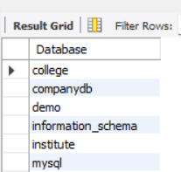
- Create a table Employees with the following columns:
Employees (EmpID (Integer, Primary Key), EmpName, Salary, JoinDate )
CREATE TABLE Employees(
EmpID INT PRIMARY KEY,
EmpName VARCHAR(20),
Salary INT,
JoinDate DATE
);
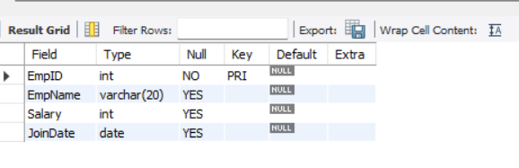
- Create a table Departments with:
Departments (DeptID (Integer, Primary Key), DeptName)
CREATE TABLE Departments(
DeptID INT PRIMARY KEY,
DeptName VARCHAR(20)
);
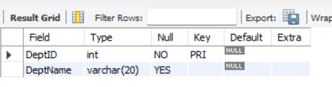
- Add a column Email (VARCHAR(100)) to the Employees table.
ALTER TABLE Employees ADD COLUMN Email VARCHAR(100);
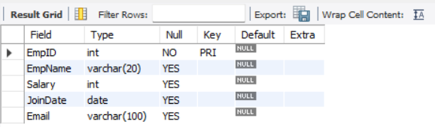
- Add a column dept_location to the Departments table.
ALTER TABLE Departments ADD COLUMN dept_location VARCHAR(30);
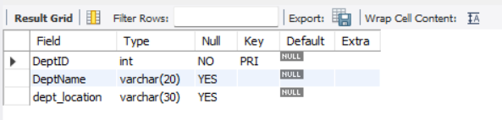
- Add a NOT NULL Constraint to the Phone column
ALTER TABLE Employees ADD COLUMN Phone INT NOT NULL;
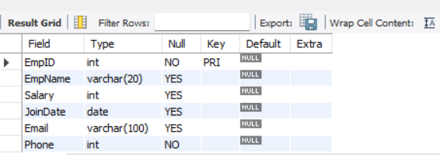
- Change the size of the EmpName column from VARCHAR (50) to VARCHAR (100).
ALTER TABLE Employees MODIFY EmpName VARCHAR(100);
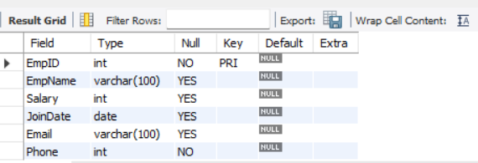
- Drop the primary key Constraint from Departments
ALTER TABLE Departments DROP PRIMARY KEY;
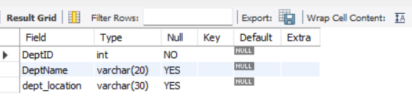
- Create a foreign key constraint between two tables
ALTER TABLE Employees ADD COLUMN DeptID INT;
ALTER TABLE Employees ADD constraint fk_dept FOREIGN KEY(DeptID) REFERENCES Departments(DeptID);
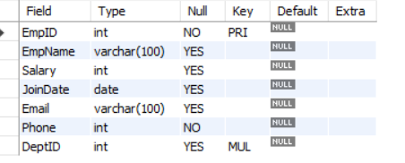
- Rename the column EmpName to EmployeeName.
ALTER TABLE Employees RENAME COLUMN EmpName to EmployeeName;
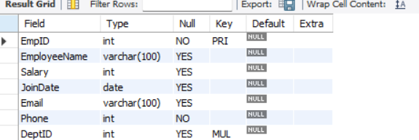
- Apply a CHECK constraint on the Age and Salary columns.
ALTER TABLE Employees ADD COLUMN Age INT;
ALTER TABLE Employees ADD constraint chk_age CHECK(Age>=18);
ALTER TABLE Employees ADD constraint chk_salary CHECK(Salary>0);
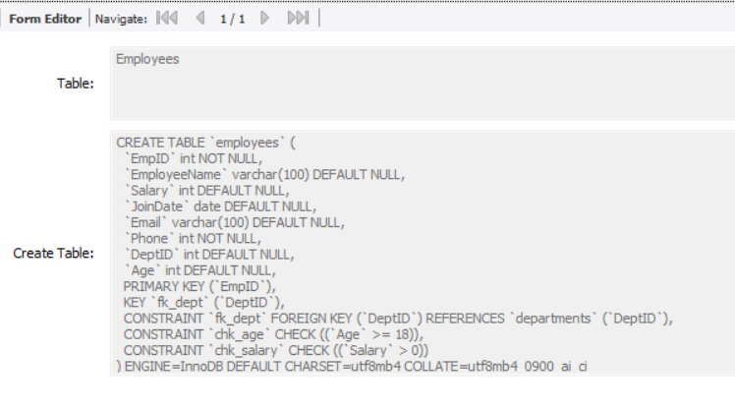

- Remove the Phone column from the Employees table.
ALTER TABLE Employees DROP COLUMN Phone;
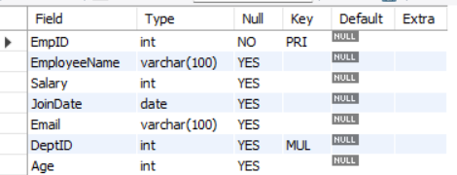
- Rename the table Employees to EmployeeDetails.
RENAME TABLE Employees To EmployeeDetails;
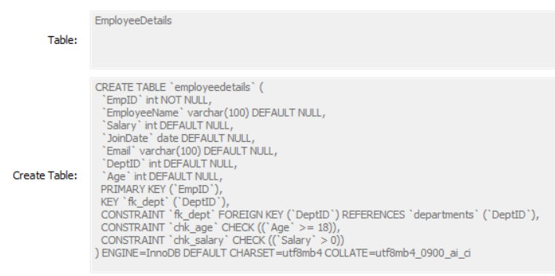
- Drop the CHECK constraints.
ALTER TABLE EmployeeDetails DROP constraint chk_age;
ALTER TABLE EmployeeDetails DROP constraint chk_salary;
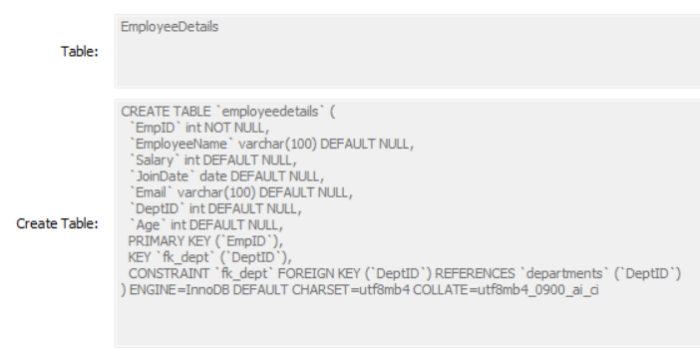
- Delete the Departments table permanently.
DROP TABLE Departments;
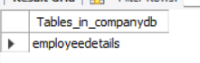
- Drop the database.
DROP DATABASE CompanyDB;
